JEREMIAH NYAGAH NATIONAL POLYTECHNIC
ELECTRICAL AND ELECTRONIC DEPARTMENT
AUTOMATE AN ELECTRICAL MACHINE
ENG/OS/PO/CR/05/6
CBET/EE/23S/6
END OF TERM EXAM

Qualification Code: 071306T4EEN
Qualification: Electrical Engineering Level 6
Unit Code: ENG/OS/PO/CR/05/6
Unit of Competency: Automate an electrical machine

INSTRUCTIONS
- Attempt ALL questions in Section A and TWO questions in section B
- Marks for each question are indicated.

SECTION A (40 MARKS)
Answer ALL questions in this section.
- State FOUR factors that must be taken into consideration when designing an automation system for electrical machines. [4 marks]
- Name THREE common components used in automation systems for electrical machines.
[3 marks]
- Explain FOUR reasons for carrying out a simulation before implementing an automation system. [4 marks]
- List TWO documents typically kept by an automation system engineer. [2 marks]
- Distinguish between open-loop and closed-loop control systems, [4 marks]
- List THREE tools used during the installation of automation components. [3 marks]
- Using a labeled diagram, differentiate between ladder logic and function block diagram programming languages used in PLCs. [4 marks]
- Define the following terms as used in automation: [3 mark ]
- Timer
- Counter
- Scan time
- Compare wired and wireless communication in automation systems, giving one application example for each. [4 marks]
- Draw the Logo 8 Siemens PLC connection/wiring diagram of a DOL motor starter control circuit in figure 1. [4 Marks]
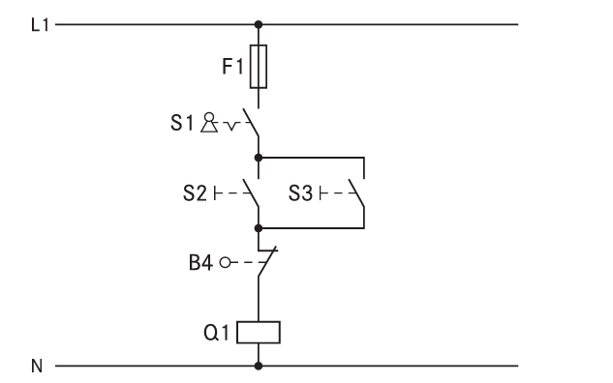
Figure 1
- Figure 2 shows a PLC module. Name the parts labeled A, B , C D and E [5 marks]

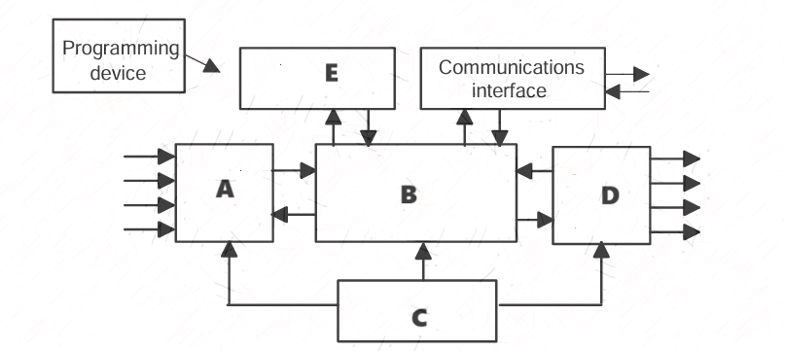
Figure 2

SECTION B (40 MARKS)
Answer TWO questions from this section.
- a) Explain the procedure for programming a PLC to automate an electrical machine, including steps like logic design, coding, and simulation. [8 Marks]
b) Parts are moving on the conveyor from one process line to other with a constant speed. Out of 1000 part, one part is taken out for quality check. Implement automation of this process in PLC using any programming language.
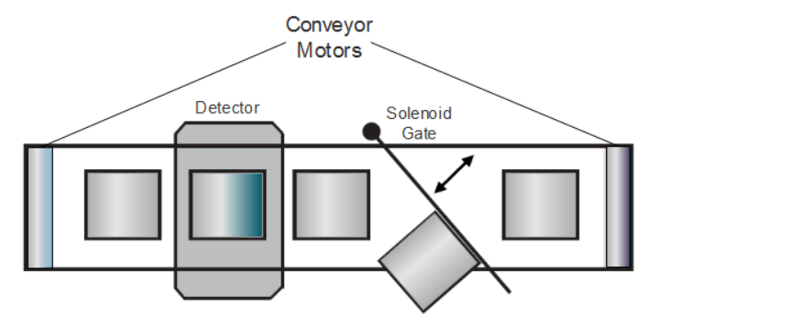
Figure 3
- a) With aid of diagram describe FOUR sensors used in automation with diagrams.
b) Tower lamps control system works as follows;
- When switch 1 is pressed, lamps 1,2, and 3 get on,
- When switch 2 is pressed, lamps 4 and 5 get on,
- When switch 3 is pressed, lamps 1, and 5 will get off.
Develop a PLC program to control this operation [12 Marks]
- a) Discuss FOUR advantages of using PLCs over traditional relay-based control systems.
[8 Marks]
b) A traffic light has red, amber, and green lamps. A red lamp gets on for 5 sec, then an amber lamp gets on for 2 sec and finally, the green lamp will get on for 5 sec. This cycle will continue for 1 minute. Develop a PLC program to perform the operation.
[12 Marks]

GOOD LUCK

